.

**S.OFTWARE REQUIREMENT SPECIFICATION**

**DOCUMENT**

**LIBRARY MANAGEMENT SYSTEM**

**Version:** Version 2.0

**ABSTRACT**

This document is intended to be the SRS for develop **SOFTWARE TO SUPPORT CALCULATIONS**

|  |  |  |  |
| --- | --- | --- | --- |
| **Project Title** | **SOFTWARE TO SUPPORT CALCULATIONS** | | |
| **Lead Institution** | **THE INTERNATIONAL SCHOOL - DUY TAN UNIVERSITY** | | |
| **Project Mentor** | **Mr. Nguyen Dang Quang Huy** | | |
| **Team Name** | **Team 6** | | |
| **Team Members** | **Nguyen Bui Ngoc Hoa** | | |
| **Vo Phi Hung** | | |
| **Thai Duy Vu** | | |
| **Kim Ngoc Viet Toan** | | |
| **Pham Minh Trang**  **Tran Mai Huy Hoang** | | |
|  | | |
| **Start Date** | Jan 25,2024 | **End Date** | Feb 20,2024 |

**ROPRIETARY INFORMATION**: The information contained in this document is the property of **TEAM 6**. Except as specifically authorized in writing by **TEAM 6**, the holder of this document shall keep all information contained herein confidential and shall protect same in whole or in part from disclosure and dissemination to all third parties

**Table of Contents**

Revision History 4

1. Introduction 6

1.1. Purpose 6

1.2. Intended Audience and Reading Suggestions 6

1.3. References 6

2. Project Overview 6

2.1. Project Description 6

2.2. Business Need 7

2.3. Project Analyst 7

2.3.1. Business Function Diagram 7

2.3.2. System Context Diagram 8

2.3.3. Data Flow Diagram 9

2.4. Software Requirement Specification 11

2.4.1. High level Fucntional Requirement (FR) 11

2.4.2. Stakeholders 13

2.4.3. Usecase 14

2.4.3.1. <<Library Management>> Use Case Diagram Overview 15

2.4.4. List of use cases 15

2.4.5. Use Case Specification 15

*UC 01: Login* 15

*[UC 02: Search books](#_Toc32367)* [....17](#_Toc32367)

*UC 03: Borrow books* 18

*[UC 04: Manage books](#_Toc32368)* [20](#_Toc32368)

*[UC 05: Receive return books](#_Toc32368)* [22](#_Toc32368)

*[UC 06: Manage readers](#_Toc32368)* [24](#_Toc32368)

*[UC 07: Search information about readers](#_Toc32368)* [25](#_Toc32368)

*[UC 08: Statistical report on borrowing books](#_Toc32368)* [26](#_Toc32368)

*[UC 09: Make a reader card](#_Toc32368)* [28](#_Toc32368)

*[UC 10: Card renewal for readers](#_Toc32368)* [29](#_Toc32368)

*[UC 011: Reader statistics report](#_Toc32368)* [31](#_Toc32368)

*[UC 012: Report ,statistics of books received](#_Toc32368)* [33](#_Toc32368)

2.4.6. Software Quality Attributes 35

2.4.6.1. Usability 35

2.4.6.2. Reliability 35

2.4.6.3. Security 35

2.4.6.4. Maintainability 35

2.4.6.5. Portability 35

2.4.6.6. Performance 35

2.5. Software Design Description 36

2.5.1. Sequence Diagrams 36

2.5.1.1.

2.5.1.2.

2.5.2. Activity Diagrams 42

2.5.2.1.

2.5.3. Class Diagram 51

Appendix A: Glossary 51

# Revision History

|  |  |  |  |  |
| --- | --- | --- | --- | --- |
| **Date** | **Change Iterm** | **Description** | **by** | **Version** |
| **25/1/2024** | Get requests from customers | After preparing the questions about the request and received the request from the customer | Pham Minh Trang | Version 1.0 |
| **26/1/2024** | Start team meeting | Meet and refer to a number of training points, read through the training points and focus on project implementation, the team can fully understand the system requirements to create | Nguyen Bui Ngoc Hoa , Vo Phi Hung , Thai Duy Vu , Kim Ngoc Viet Toan, Pham Minh Trang | Verison 1.0 |
| **26/1/2024** | Job analysis | Through specific requirements, analysis, clearly speaking, the leader needs to prepare in advance for the members. | Pham Minh Trang, Kim Ngoc Viet Toan | Verison 1.0 |
| **26/1/2024** | Share the work | Get BFD, contextual diagram  The mandatory rules of the project | Nguyen Bui Ngoc Hoa, Vo Phi Hung, Thai Duy Vu, Kim Ngoc Viet Toan, Pham Minh Trang | Verision 1.0 |
| **22/2/2024** | Mr. Huy corrected | Fix BFD, DFD, USE CASE, font size, font pattern, context diagram, more clearly about the missing and suggest some important things | Tuong Thi Thuy Hang | Verision 1.0 |
| **5/2/2024** | Editing group | BFD, DFD, USE CASE, Context Diagram, font size, font | Nguyen Bui Ngoc Hoa, Vo Phi Hung, Thai Duy Vu, Kim Ngoc Viet Toan, Pham Minh Trang | Verision 1.0 |
| **26/1/2024** | Complete DFD, System Context Diagram | DFD 1 and 2, System Context Diagram | Pham Minh Trang, Kim Ngoc Viet Toan | Verision 2.0 |
|  |  |  |  |  |

# Introduction

## Purpose

This document outlines the specifications for a basic computing system, encompassing fundamental arithmetic operations such as addition, subtraction, multiplication, division, and modulo division. Additionally, it includes a reset button to restart operations from the beginning. The primary objectives of this document are as follows:

• To assist project managers have an overall view of the system as well as perform tasks in an optimized way

• To Describes the control architecture and use cases in detail. Based on this document

Architectural analysts and designers will be able to develop the system easily.

• Intended Audience

## Intended Audience and Reading Suggestions

|  |  |
| --- | --- |
| Intended Audience | everyone |
| Project manager | High level functional requirement |
| Architect analyst and designer | Overall description and user cases to architect and design the system |
| Quality control | Overall description and user cases |
|  |  |

## References

# Project Overview

## Project Description

A compact computer system is designed to handle basic math operations like addition, subtraction, multiplication, and division. Its main goal is to assist students, learners, and workers in performing math tasks quickly and accurately. This computer is capable of dealing with complex calculations involving multiple numbers, reducing the risk of errors caused by human input. This functionality not only saves time and effort but also enhances overall efficiency, especially in fields that require extensive mathematical computations..

## Business Need

This system had a number of advantages:

- Facilitates swift and precise mathematical calculations.

- Saves time and guarantees accuracy throughout the calculation process.

- Assists students and individuals working on tasks involving intricate calculations or demanding high precision.

## Project Analyst

### Business Function Diagram

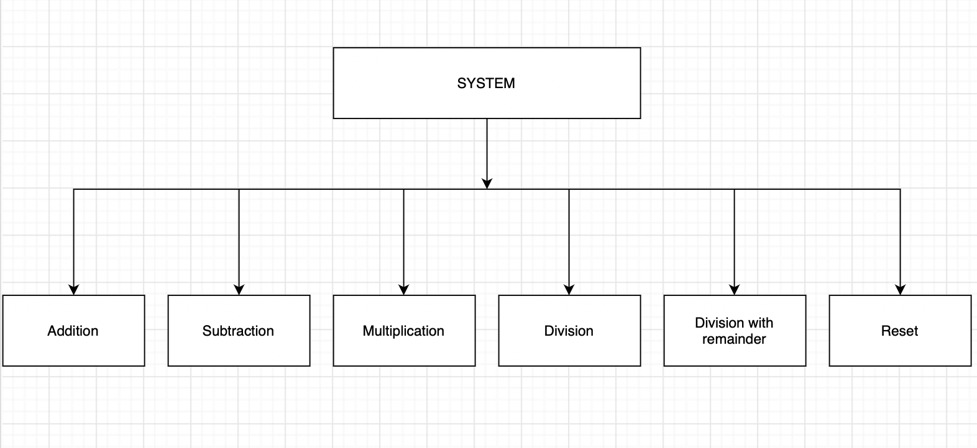

**2.3.2 System Context Diagram**

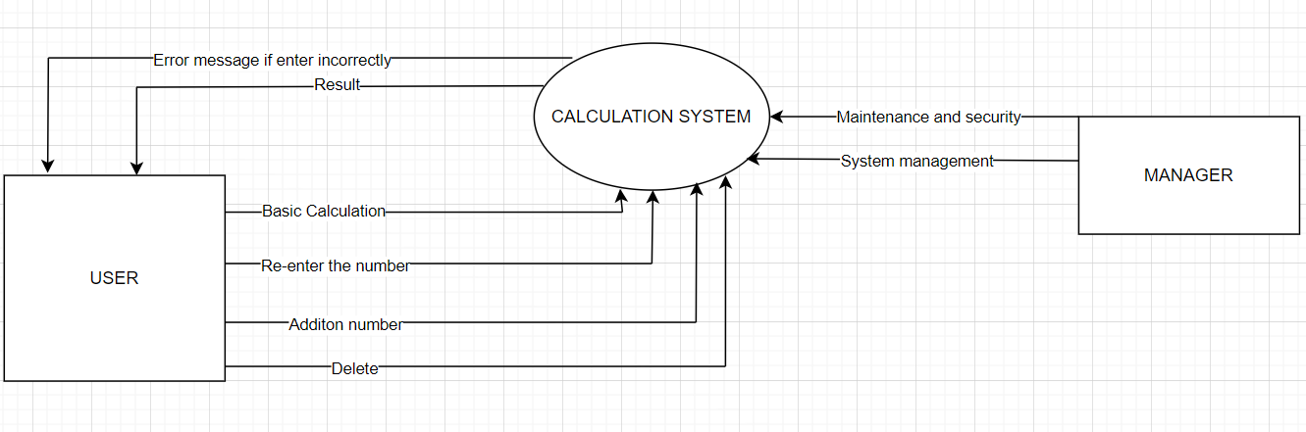

**2.3.3 Software Requirement Specification**

|  |  |  |
| --- | --- | --- |
| FR1.1 | **Title** | Calculation |
| User | This feature allows users to perform basic calculations such as +, -,*,/ |
| Description | The system requires you to enter the number to calculate and can use basic calculations to calculate. If you enter , it is not a number, the system will ask you to re-enter |
| FR1.2 | **Title** | Maintenance |
| System Management | This use case enables system management |
| Description | If the system malfunctions or an error occurs. System managers are allowed to intervene and fix errors. Additionally, it ensures security and helps users have a better experience |

**2.3.4 Stakeholder**

|  |  |
| --- | --- |
| **Stakeholder** | **Description** |
| Users (Guest,Manager System) | System users |

**2.3.5 Use Case**

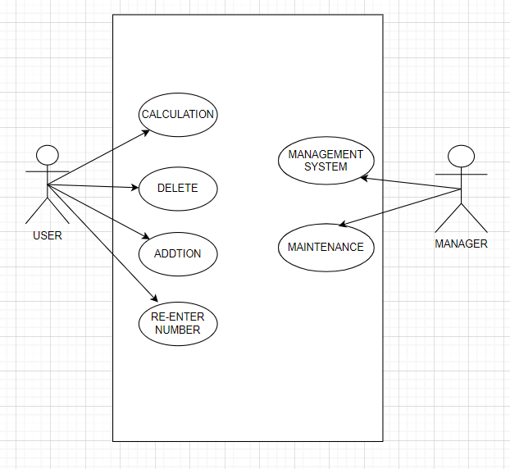

**2.3.6 List of use case**

|  |  |  |
| --- | --- | --- |
| **Use case ID** | Name use case | Functional Req. |
| UC.01 | Calculation | FR.1 |
| UC.02 | Addtion | FR.2 |
| UC.03 | Delete | FR.3 |
| UC.04 | Re-enter Number | FR.4 |
| UC.05 | System management | FR.5 |
| UC.06 | Maintenance | FR.6 |

**2.3.7 User Story**

|  |
| --- |
| As a user, I want to have the function to calculate sums, so that I can use it when I forget or can't calculate. |
| Actor: user |
| Story: when people need to calculate or calculate something related to money, they will need to use this feature. |
| * Condition: * - If you enter the wrong number (not a number), a message will appear to re-enter * - If entered correctly, the sum of those two numbers will be displayed * - After completing the calculation, if you want to calculate another number, there is a feature to delete the number * - When you are calculating and accidentally enter the wrong number to calculate, there is a number re-entry feature that allows you to re-enter * - If you want to enter another number to calculate, there is an add number feature that allows you to enter 1 more digit. |

|  |
| --- |
| ID:US02 |
| As a manager, I want to have a system management function, so that when I want to maintain or fix errors, I will use it. |
| Actor: Admin |
| Story: When a system error occurs or the system is interfered with by a third party, I have the right to use this feature to more easily handle system difficulties. |
| * Condition: * - If an error occurs, you will have the right to intervene in the system |

|  |
| --- |
| ID:US01 |
| As a user, I want to have the function to enter more numbers, so that when I want to enter more numbers, I can use this function. |
| Actor: user |
| Story: whenever a user wants to enter an additional number for calculation, they will use this feature |
| * Condition: * - If you enter the wrong number (not a number), a message will appear to re-enter * - If entered correctly, the sum of those two numbers will be displayed * - After completing the calculation, if you want to calculate another number, there is a feature to delete the number * - When you are calculating and accidentally enter the wrong number to calculate, there is a number re-entry feature that allows you to re-enter * - If you want to enter another number to calculate, there is an add number feature that allows you to enter 1 more digit. |

|  |
| --- |
| ID:US01 |
| As a user, I want to have the function to delete numbers so that when I want to recalculate the number, I can use this function |
| Actor: user |
| Story: Story: when a user wants to delete a number for calculation, the feature will support the user. |
| * Condition: * - If you enter the wrong number (not a number), a message will appear to re-enter * - If entered correctly, the sum of those two numbers will be displayed * - After completing the calculation, if you want to calculate another number, there is a feature to delete the number * - When you are calculating and accidentally enter the wrong number to calculate, there is a number re-entry feature that allows you to re-enter * - If you want to enter another number to calculate, there is an add number feature that allows you to enter 1 more digit. |

### 2.3.8 Use Case Specification

##### UC 01: Enter Number

1. Use Case Diagram

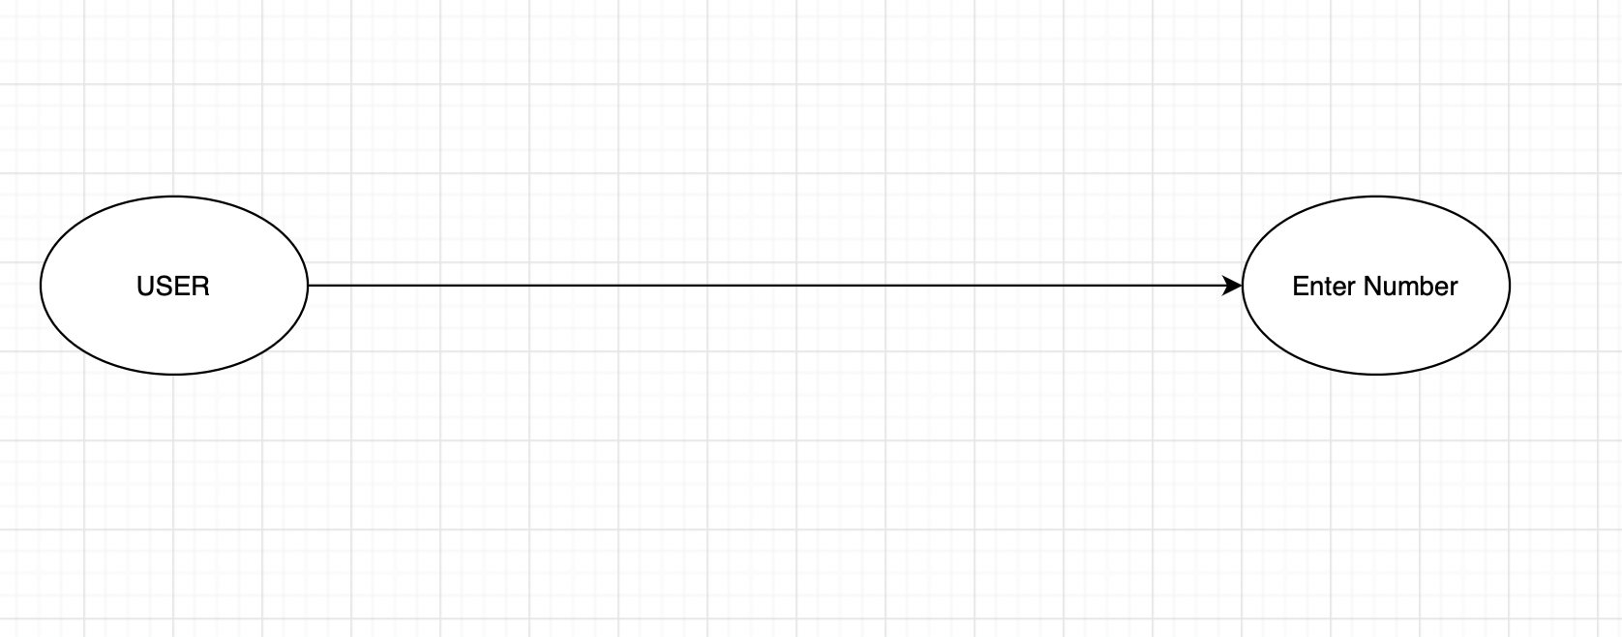

b) Use Case Specification

|  |  |  |  |
| --- | --- | --- | --- |
| Use case ID | UC.01 | | |
| Use case name | **Enter Number** | | |
| Create by | Pham Minh Trang | **Last updated by** | Pham Minh Trang |
| Date created | Jan 26, 2024 | **Date last updated** | Jan 30,2024 |
| Actor | Users of the system : User | | |
| Description | The person needs to enter the numbers to be calculated to be able to receive the results after calculation. | | |
| Trigger | Click on the 2 textfiled bars of Number 1 and number 2 | | |
| Pre-condition | None | | |
| Post-condition | If only enter numbers, you will receive the most accurate result. However, if you enter letters or a combination of letters and numbers, the system will display an error. | | |
| Main Success Scenario: | **Step** | **Actor Action** | **System Response** |
| 1 | Click on the 2 textfile bars of Number 1 and Number 2 |  |
|
|
| Exception | **Step** | **Actor Action** | **System Response** |
| 1 | If you enter characters or both numbers and characters. | Display error message |
| Priority | High | | |
| Business rule | N/A | | |
| Description: | When users want to calculate they need to enter the number to calculate into the system. | | |

##### UC 02: Calculate

1. Use Case Diagram

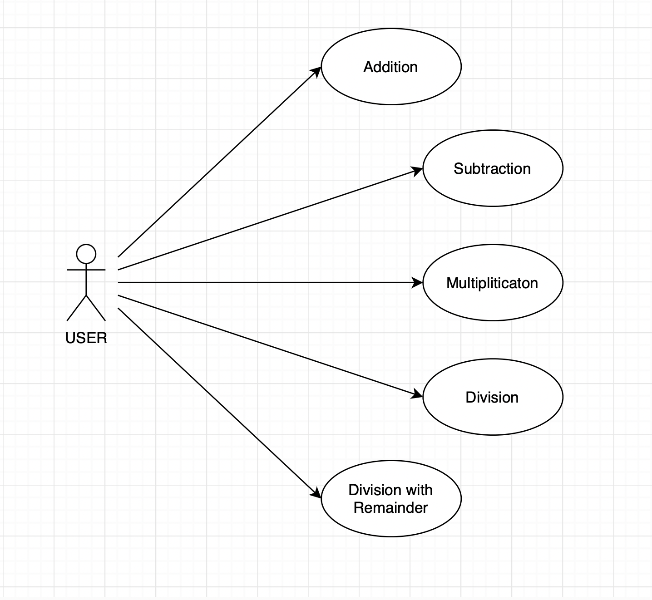

b) Use Case Specification

|  |  |  |  |  |  |
| --- | --- | --- | --- | --- | --- |
| Use case ID | UC.02 | | | | |
| Use case name | **Calculate** | | | | |
| Create by | Pham Minh Trang | | **Last updated by** | | Pham Minh Trang |
| Date created | Jan 26,2024 | | **Date last updated** | | Jan 27,2024 |
| Actor | User | |  | | |
| Description | Once the user inputs the correct number, you can proceed to select a calculation to determine the result. | | | | |
| Trigger | The required number has been entered correctly. | | | | |
| Pre-condition | Before calculating, users need to enter the correct number required by the system. | | | | |
| Post-condition | Users will obtain results when they input numbers in accordance with the system's specifications. | | | | |
| Main Success Scenario: | **Step** | **Actor Action** | | **System Response** | |
| 1 | The user must click on one of the five calculation“**Addition, Subtraction, Multiply, Divide , Division with Remainder**”buttons. | | The system will display the results if the correct number is entered. | |
|
|
| Alternative Scenario | **Step** | **Actor Action** | | **System Response** | |
| 1 | The user must click on one of the five calculation “**Addition, Subtraction, Multiply, Divide, Division with Remainder**” buttons. | | The system will display the results if the correct number is entered. | |
|
|
| Exceptions | **Step** | **Actor Action** | | **System Response** | |
| 1 | None | | None | |
|
|
| Priority | High | | | | |
| Business rule | N/A | | | | |
| Description: | When the user has entered the correct number, you can choose a calculation to calculate the result. | | | | |

##### UC 03: Reset

1. Use Case Diagram

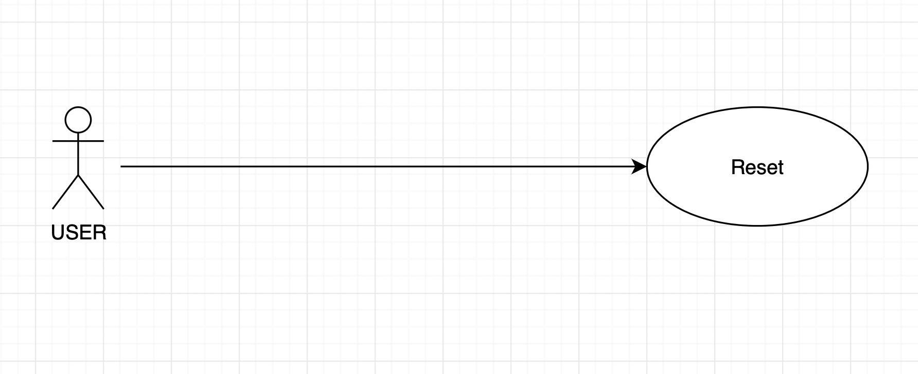

b) Use Case Specification

|  |  |  |  |  |  |
| --- | --- | --- | --- | --- | --- |
| Use case ID | UC.03 | | | | |
| Use case name | Reset | | | | |
| Create by | Pham Minh Trang | | **Last updated by** | | Pham Minh Trang |
| Date created | Jan 26,2024 | | **Date last updated** | | Jan 30,2024 |
| Actor | User | |  | | |
| Description | Users can press the reset button if they want to re-enter two Number 1 and Number 2 | | | | |
| Trigger | The required number has been entered correctly. | | | | |
| Pre-condition | None | | | | |
| Post-condition | None | | | | |
| Main Success Scenario: | **Step** | **Actor Action** | | **System Response** | |
| 1 | Click “Reset” button. | | The system will delete 2 Number 1 and Number 2 for the user to re-enter. | |
|
|
| Alternative Scenario | **Step** | **Actor Action** | | **System Response** | |
| 1 | Click “Reset” button. | | The system will delete 2 Numbers 1 and Number 2 for the user to re-enter. | |
|
|
| Exceptions | **Step** | **Actor Action** | | **System Response** | |
| 1 | None | | None | |
|
|
| Priority | High | | | | |
| Business rule | N/A | | | | |
| Description: | Users can press the “Reset” button if they want to re-enter two Numbers 1 and Number 2 | | | | |

**2.4.6 Activity Diagram**

**1. Login**

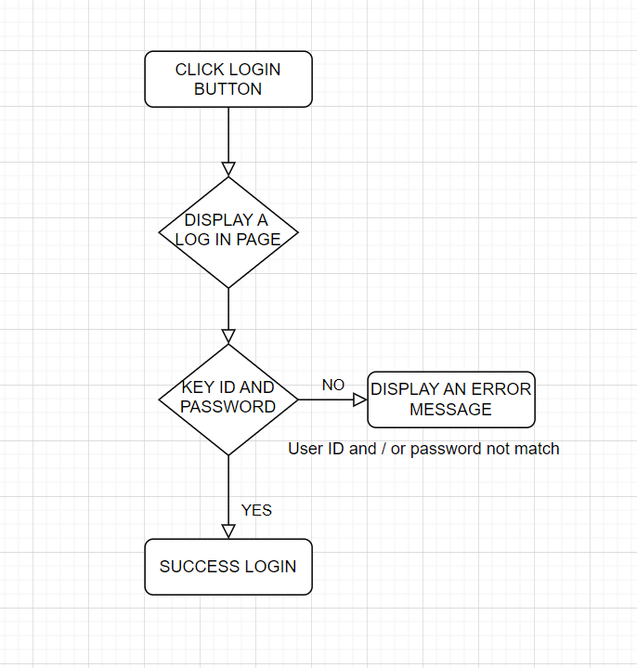

# 2.System

